

**Pay and View   
Your Rice Water Supply & Sewer Service Bill Electronically**

**GO GREEN…**

Help save resources by opting out of paper bills.

* Pay by from your checking or savings account
* Pay by credit or debit card
* Pay immediately, schedule a payment or set up Auto-Pay
* View the amount you owe online or on the payment app
* View your utility bill online; you can also print bills
* Stop receiving paper bills; you will receive an email each time a new bill is ready for viewing

Group small w AmEx.png

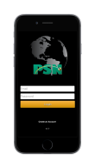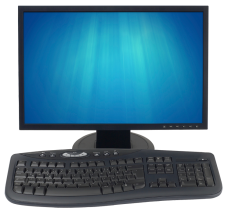

* **Pay**
* **View Bill**
* **View Balance Due**
* **Pay**
* **Hear Balance Due**
* **Pay**
* **View Balance Due**

**Download “PSN Payments”**

Go to the App Store® or Google Play™ to download the app. Register online to set up your password before using the app.

**Go to www.ricewatersupply.com**

Click on the bill payment link. You will go to our payment processor’s website where you should register and make your payment. Future payments are just 3 easy steps. You can also view your bill online.

**Call 1-877-885-7968**

On your first call, you will set up your payment account. After that, automated phone payments are 4 simple steps.

*We use Payment Service Network (PSN) for our electronic payment processing.   
PSN has been certified as maintaining the highest level of security as required by the credit   
card industry. PSN is a US company with all services performed in the US.*

Authorized Processor